GRADES 1 to 12  DAILY LESSON LOG | School: |  | Grade Level: | V
 | Teacher: |  | Learning Area: | MATHEMATICS
 | Teaching Dates and Time: | MARCH 2 – MARCH 6, 2020 (WEEK 7) | Quarter: | 4th Quarter

 | MONDAY | TUESDAY | WEDNESDAY | THURSDAY | FRIDAY
- OBJECTIVES
- Content Standards | demonstrates understanding of area, volume and temperature. | demonstrates understanding of area, volume and temperature. | demonstrates understanding of area, volume and temperature. | demonstrates understanding of area, volume and temperature. | Weekly Test
- Performance Standards | is able to apply knowledge of area, volume and temperature in mathematical problems and real-life situations. | is able to apply knowledge of area, volume and temperature in mathematical problems and real-life situations. | is able to apply knowledge of area, volume and temperature in mathematical problems and real-life situations. | is able to apply knowledge of area, volume and temperature in mathematical problems and real-life situations.
- Learning Competencies/Objectives  Write the LC code for each | Interprets data presented in different  kinds of line graphs (single to doubleline  graph).  M5SP-IVh-3.5/Page 65 of 109 | Solves routine and non-routine  problems using data presented in a line  graph.  M5SP-IVh-4.5/Page 65 of 109 | Draws inferences based on data  presented in a line graph. M5SP-IVh-5.5
- CONTENT | •Interpreting data in a bar graph. | Solving Routine and Non-routine Problems Using Data Presented in a Line Graph | Drawing Inferences Based on Data Presented in a Line Graph
- LEARNING RESOURCES
- References
- Teacher’s Guide pages |  | Mathematics Teachers Guide IV pp. 346 | Mathematics Teachers Guide IV pp. 346
- Learner’s Material pages | K to 12 Grade 5 Curriculum Guide, M5SP-IVh-3. | K to 12 Grade 5 Curriculum Guide, M5SP-IVh-3. | K to 12 Grade 5 Curriculum Guide, M5SP-IVh-5.5
- Textbook pages | Lesson Guide in Elementary Mathematics V pp.501-507 | Mathematics Teachers Guide IV pp. 346
- Additional Materials from Learning Resource (LR) portal
- Other Learning Resources | graph, grid board | graph, grid board | graph, grid board
- PROCEDURES
- Reviewing previous lesson or presenting the new lesson | 1.Drill  Drill on skip counting by 2s, 5s, 10s, etc.  2.Review  Conduct a review on interpreting data presented in a bar graph.  Gemma’s First Quarter Grade on the Major Subjects  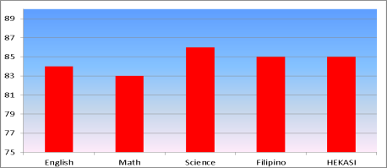  a.In what subject did Gemma have the highest grade?  b.In what subject did she have the lowest grade?  c.In what subjects did she get the same average grade?  d.What is the difference between the highest and lowest grade she got on the first quarter?  e.What was her average score on the five subjects? | 1.Drill  Conduct a drill on reading and interpreting a graph.  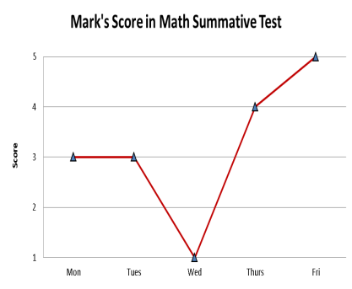  1.What is the graph about?  2.On what day did he get the lowest score in Math?  3.On what days were his scores the same?  4.When did he get a perfect score?  5.What was his average score for the week?  .Review  Conduct review onthe parts of a line graph.  Have them construct a line graph using the following data:  Results in an Experiment  Weeks Height of Plant  1 1 cm  2 2 cm  3 2.5 cm  4 3.5 cm  5 4 cm  6 6 cm | A.Preliminary Activities  1.Drill  Each group will use the grid board to plot several points on the graph.  At the signal “Go”, they will start plotting. The first group to finish will win the game. Let the first group describe the figure they form based on the points they plotted on the graph.  (1, 20)  (3, 40)  (4, 60)  (5, 120)  (7, 120)  (7, 60)  (4, 60)  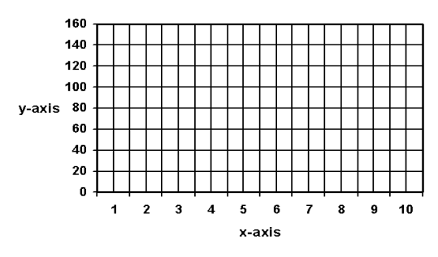  2.Review  Which of the following line graphs below best describe the height of a child? Defend your answer.  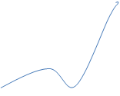
- Establishing a purpose for the lesson | 3.Motivation  How many of you are observant with the day’s temperature?  Why does a weatherman inform us about temperature readings?  Why do you think there is a need to check the day’s temperature from time to time? | 3.Motivation  Is it important to keep track of your performance in school? What do you do in order to maintain good performance track? | 3.Motivation  Is it important to get good grades in school?  What will you do in order to attain it?
- Presenting examples/instances of the new lesson | 1.Presentation  Present a line graph with complete parts and let the pupil interpret the data.  Ask:  1.What are the parts of a line graph?  2.Looking at the data, can you interpret what is presented by the graph? How?  3.How does a line graph help in data presentation?  4.Is it important to have an accurate data? Why? | 1.Presentation  Present a line graph to the class.  Ella’s Grade in Math  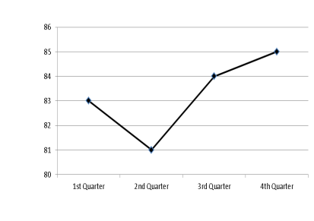  Ask: In what quarter did Ella get the lowest grade? What about the highest grade?  Why do you think Ella got the lowest grade during the 2nd Quarter?  What will you do in order to get good grades? | 1.Presentation  Ana’s Grade in Math  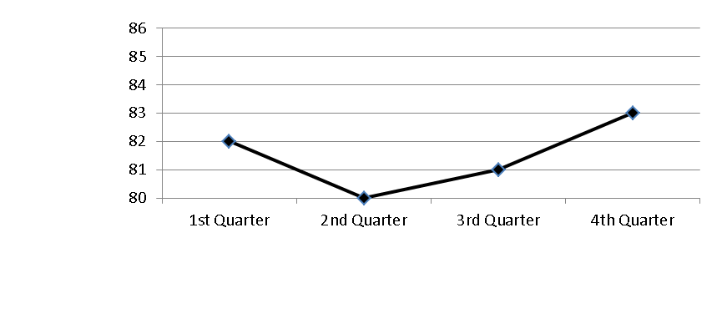  a.At what quarter did Ana get the highest grade in Math?  b.What is the lowest grade she got?  c.Why do you think Ana got low grade on the second quarter?
- Discussing new concepts and practicing new skills #1 | 2.Performing the Activities  Group the pupils into five.  Give activity sheets involving line graph to each group for interpretation.  Ask each group to work together in interpreting the data on the graph. Once finished, the assign member will post their work on the board and discuss their answer.  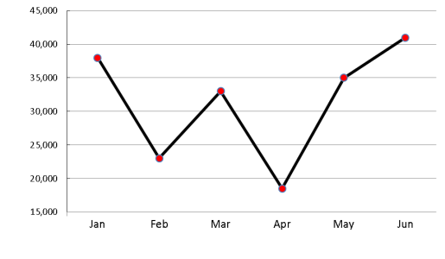  See more different graphs in LM | 2.Performing the Activities  Divide the class into groups. Give them enough time to solve problems using the data presented in a line graph. After few minutes, they are required to present their output.  Mr. Sanchez’s Monthly Sales  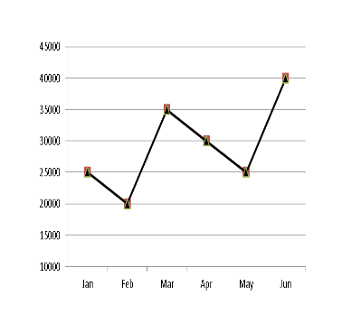  Use the data in the line graph to answer the following questions.  1.What was the sale for the first three consecutive months?  a.What is asked?  b.What facts are needed to solve the problem?  c.What operation will you use?  d.What is the number sentence?  e.What is the complete answer?  2.How much more was his sale in March than in February?  a.What is asked?  b.What facts are needed to solve the problem?  c.What operation will you use?  d.What is the number sentence?  e.What is the complete answer?  3.What was the difference between the highest and lowest sale?  a. What is asked?  b.What facts are needed to solve the problem?  c.What operation will you use?  d.What is the number sentence?  e.What is the complete answer?  4.What was his total sale from January to June?  a.What is asked?  b.What facts are needed to solve the problem?  c.What operation will you use?  d.What is the number sentence?  e.What is the complete answer?  5.What was his average sale for six months?  a.What is asked?  b.What facts are needed to solve the problem?  c.What operation will you use?  d.What is the number sentence?  e.What is the complete answer? | 2.Performing the Activities  Give each group activity sheets involving line graph for interpretation. Ask the group to work together in interpreting the data and make inferences out of it. After they have finished, the leader of each group will display the output on the board and discuss their answers.  Paulo’s Weight  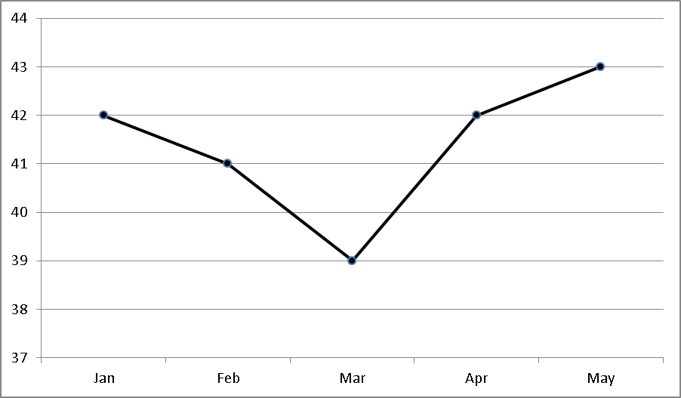
- Discussing new concepts and practicing new skills #2 | . Processing the Activities  Each group will present their interpretation of the graph. Then ask:  a.How did you find the activity?  b.How were you able to interpret the graph?  Discuss with the pupils how to use the data to interpret the graph. | Processing the Activities  Allow each group to present their output.  Ask: How did you find the activity?  How did you solve the problem?  Expected Answer:  Using the four-step plan in solving the problem  • Understand  • Plan  • Solve  • Check and Look Back  Discuss how to solve routine and non-routine problems. | 3.Processing the Activities  Each group will discuss their work. After all the groups have presented their answers to the task given, ask:  How did you find the activity?  How did you make inferences based on the data observed on the line graph?  Discuss with the pupils how to make inferences based on the data.
- Developing mastery  (Leads to Formative Assessment 3) | Reinforcing the Concept and Skill  A.Discuss the presentation under Explore and Discover on pages ___of LM Math Grade V.  B.Have the pupilswork on items under Get Moving and the items under Keep Moving on pages ____, LM Math Grade 5. Check the pupil’s answers. | 4.Reinforcing the Concept and Skill  Discuss the presentation under Explore and Discover on pages ___of LM Math Grade V.  Have the pupils work on items under Get Moving and the items under Keep Moving on pages ____, LM Math Grade 5. Check the pupil’s answers. | 4.Reinforcing the Concept and Skill  Discuss the presentation under Explore and Discover on page __, LM Math Grade 5.
- Finding practical applications of concepts and skills in daily living | Applying to New and Other Situations  Have the pupils do the items under the activity on Apply Your Skills on page ____, LM Math Grade 5 | Applying to New and Other Situations  Let the pupils do the problems under Apply your Skills on page ___, LM Math5. | Applying to New and Other Situations  Ask the pupils to work on items under Apply your Skills on page ___, LM Math Grade 5
- Making generalizations and abstractions about the lesson | Summarizing the Lesson  Lead the pupils to give the generalization of the lesson by asking: What are the parts of a line graph? Why is it useful? How do we interpret data presented on a line graph?  •A line graph has a title, information on the x-axis (horizontal axis) and information on the y- axis (vertical axis).  •Changes in the data presented are easily seen on a line graph.  •To read and interpret the data presented in a line graph, we usually compare the data in terms of size and amount. | Summarizing the Lesson  Lead the pupils in generalizing the following:  Routine problems are problems that follow standard procedure in solving word problems:  Understand:  •What does the problem ask for?  •What are the given data?  •What is the word clue?  Plan  •What operation is/are to be used?  •What is the mathematical sentence?  Solve  •Show how the solution is done using the operation.  Check  •Check if the answer is correct.  •State the final answer.  Nonroutine problems are problems that can be solved even without following the steps or procedure | 5.Summarizing the Lesson  Guide the pupils to give the following generalization.  To draw inferences it is important to:  •observe the parts of the graph  •understand the relationship being illustrated on the graph  •make prediction based on the describe situation presented by the data on the graph
- Evaluating learning | C.Assessment  Study the line graph, and then answer the question below.  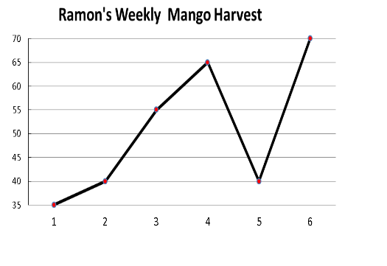  a.What is the title of the graph?  b.How many mangoes were harvested for the first two weeks?  c.In what week was there the greatest amount of harvest?  d.What is the least amount of mango harvested?  e.What is the total amount of harvest for six weeks? | C.Assessment  Use the data in the line graph to answer the following questions.  Ramon’s Electric Consumption  1.What is the total electric consumption from January to June?  a.What is asked?  b.What facts are needed to solve the problem?  c.What operation will you use?  d.What is the number sentence?  e.What is the complete answer?  2.If the cost of electricity per kilowatt is Php. 14.00, how much would Ramon pay for the month of May?  a.What is asked?  b.What facts are needed to solve the problem?  c.What operation will you use?  d.What is the number sentence?  e.What is the complete answer? | C.Assessment  Study the line graph them answer the question below.  Baskets made During Practice  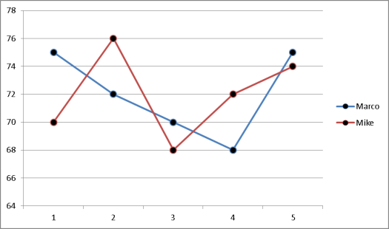  a.How many baskets did each one make during the third session?  b.Who made more baskets on the fourth session?  c.What is their average number of baskets during the five-day session of practice?  d.How many baskets did each one make all throughout the session?  e.Who is more successful in making a basket?
- Additional activities for application or remediation | Study this graph carefully, and then answer the questions that follow.  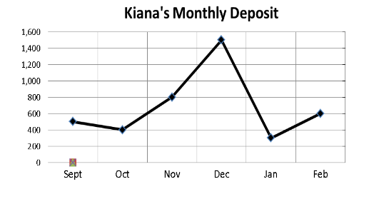  1.What is the graph about?  2.How much was her initial deposit?  3.In which month was her bank deposit greatest?  4.What was her average deposit??  5.What was her total deposit for six months? | 1.What is the total number of immigrants starting 2010 up to 2015?  2.What is the average number of immigrants for the last three years?  Immigrants Admitted in One Country from 2010-2015  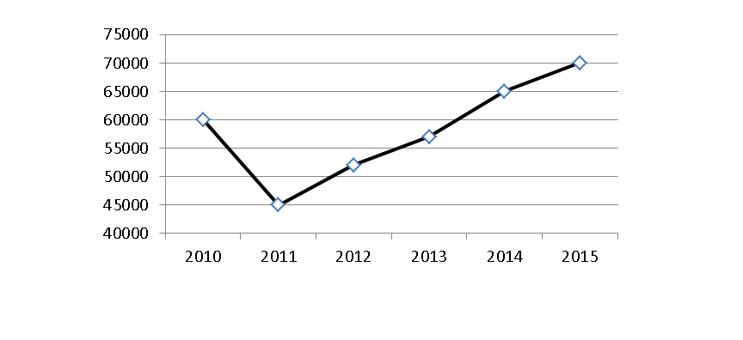 | Prepare for the 4th periodical test
- REMARKS
- REFLECTION
- No. of learners who earned 80% in the evaluation
- No. of learners who require additional activities for remediation who scored below 80%
- Did the remedial lessons work? No. of learners who have caught up with the lesson
- No. of learners who continue to require remediation
- Which of my teaching strategies worked well? Why did these work?
- What difficulties did I encounter which my principal or supervisor can help me solve?
- What innovation or localized materials did I use/discover which I wish to share with other teachers?

