GRADES 1 to 12  DAILY LESSON LOG | School: |  | Grade Level: | VI
 | Teacher: |  | Learning Area: | ENGLISH
 | Teaching Dates and Time: | MARCH 2 – MARCH 6, 2020 (WEEK 7) | Quarter: | 4TH QUARTER

 | MONDAY | TUESDAY | WEDNESDAY | THURSDAY | FRIDAY
I. OBJECTIVES
A. Content Standards | - Demonstrates understanding of various non-verbal elements in orally communicating information  - Demonstrates understanding that words are composed of different parts to know that their meaning changes depending in context  - Demonstrates understanding of verbal and non-verbal elements of communication to respond back  - Demonstrate understanding of the research process to write a variety of texts  - Demonstrates understanding that a change in stress entails a change of meaning to evaluate the speaker’s/author’s purpose and meaning  .
B. Performance Standards | - Orally communicates information, opinions and ideas effectively to different audiences for a variety of purposes  - Uses strategies to decode correctly the meaning of words in isolation and in context  - Uses a variety of strategies to provide appropriate feedback  - Uses a variety of research strategies to effectively write a variety of texts for various audiences and purposes  - Uses knowledge of stress and intonation of speech to appropriately evaluate the speaker’s intention, purpose and meaning
C. Learning Competencies/  Objectives | Summarize the information from a text heard  Inferring meaning of content-specific terms using  -context clues  -affixes and roots  -other strategies | Use appropriate graphic organizer in text read | Use various types and kinds of sentences for effective communication of information/ideas  (Compound-Complex Sentence) | Conduct short research projects on a relevant issue  Make connections between information viewed and personal experiences | Compose three-paragraph persuasive essay on self-selected topic
Write the LC code for each | EN6OL-IVg-3.6  ENGV-IVg-12.3.3  ENGV-IVg-12.4.1.3  EN6V-IVg-12.4.2.3 | EN6RC-IVg-2.15.2 | EN6SS-IVg-1.10 | EN6SS-IVg-2.3  EN6VC-IVg-1.4 | EN6WC-IVg-2.2.11
II. CONTENT  (Subject Matter) | Clarifying meaning of text heard  Inferring meaning of borrowed word  Context clues | Graphic organizer  Research projects | Compound-Complex Sentence | Used to influence viewers  Stereotypes, point of view , propaganda | Composing paragraph
III. LEARNING RESOURCES
A. References
1.Teacher’s Guide/Pages | Curriculum Guide pp 138 of227
2.Learner’s Materials Pages
3.Textbook Pages | Essentials English 6 pp.372-373 | Essentials English 6 pp.373--376 | Essentials English 6 pp.378-379 | Essentials English 6 pp. 376 | Essentials English 6 p 380
4.Additional Materials from Learning Resource(LR)portal
B. Other Learning Resources | powerpoint | Chart, worksheet | powerpoint | powerpoint | Powerpoint
III. PROCEDURES
A. Reviewing previous lesson or presenting new lesson | Arrange the jumble words to form the informational text needed in making a summary.  What tell text the all is about.  Topic the identify.  Points key the tell. | Add tion/ ion to the following words.  1.transfuse  2.progress  3.obsess  4.confess  5.televise  6.supervise | Recall what the difference between a compound sentence to a complex sentence.  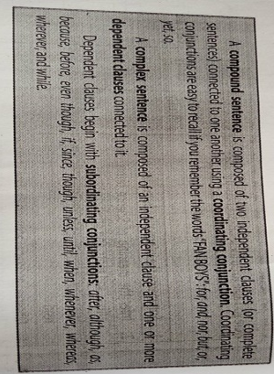 | Write the clue words in the box where they belong.  We she him my me  You he I mine her they  Them  First person Second Person Third Person | How to write a persuasive paragraph. Watch a video to know what is a persuasive paragraph?  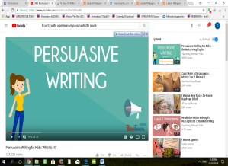
B. Establishing a purpose for the lesson | Each group will be given a picture puzzle of climate change. Then tell something about climate change . | The following underlined words are found in the story we are going to read today. Give their meaning using context clues.  - She screamed in fright and scamperd away, dropping her shawl in her hurry.  - Jump  - Run  - He grabbed the dagger which he had always brought with him.  - Gun  - Knife  - The beast trampled on her shawl, and wrenched it with its teeth as it let loose a frightening roar.  a.violent motion  b. quiet motion | Study the following sentence.  - Their parents disapproved of their relationship and tried to separate them, but forbidden love would always find a way.  - When the night came, Thisbe secretly slipped out of the house to meet Pyramus.  Identify what type of sentence are they, and why.  Original File Submitted and Formatted by DepEd Club Member - visit depedclub.com for more | Watch any one of these episodes of Jollitown at www. Youtube.com/watch?=u6jXQA18juA  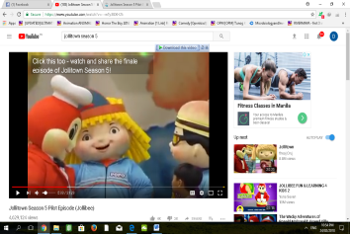  Write the important information you learned from the episode. Which part of the episode is related to your personal experience?  Original File Submitted and Formatted by DSepEd Club Member - visit depedclub.com for more | Watch another video to learn more how you can write a persuasive paragraph.
C. Presenting examples/  instances of the new lesson | Listen to the second part of the text about climate change. Summarize the information you heard by answering this question to help you identify the key points.  - What are the serious effects of climate change? | Have you heard a story about red mulberries.  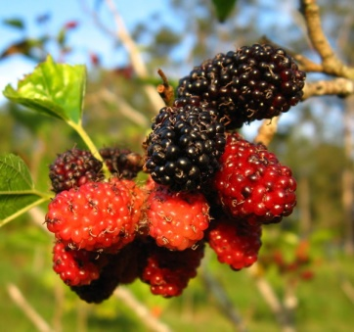  Are they edible?  Let find out why mulberries turned blood-red.  The Legend of the Red Mulberries  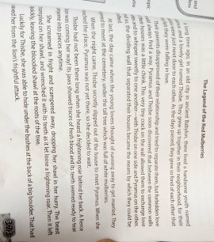  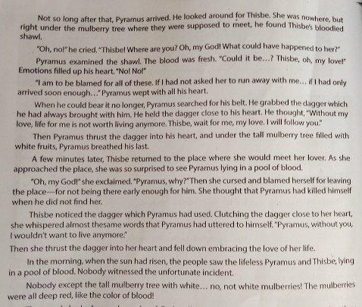  Answer the following questions:  1.Where did this story take place?  2.In what place did Pyramus and Thibe agree to meet as they planned to run way  3.What happened when Thisbe arrived at their meeting place?  4.What happened when Pyramus arrived?  5.do you believe that Pyramus and Thisbe loved each other truly and deeply? Prove your answer.  6.What could have prevented this incident from happening?  7.How do you think did the old folks explain why thwe white mulberries turned into red fruits? | Use a coordinating conjunction to join each pair of the independent clause into a compound sentence.  - Mathematics seems hard for many pupils. There are techniques for improving one’s mathematical skills.  - Zachary is an excellent student. He received a medal.  - The library is quiet place to study. We prefer to study at home.  - Some animals are endangered. Many people are working to protect them.  - Fasten your seatbelt. You might ne injured. | 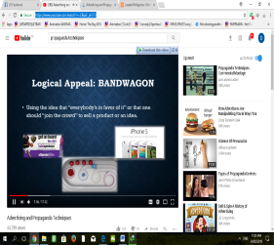  W atch another video about propaganda.  What are the different propaganda that can influence you? | Write a three=paragraph persuasive essay on any of these topics.  - Getting a cat as pet  - Visiting your hometown  - Starting a good habit  - Volunteering to Gawad Kalinga  - Avoiding junk food  - Stopping a bad habit
D. Discussing new concepts and practicing new skills #1 | Study the following words.  Erosion explosion  Revolution eruption  Conclusion abrasion  What do you notice about the following words?  The suffix –tion occurs in words of Latin origin, used to form abstract nouns from verbs to express action or a state. If the word rotation means the act of rotating, give the meaning of these terms in science that ends in –ion suffix. | Sequence the event in the story we read using graphic organizer.  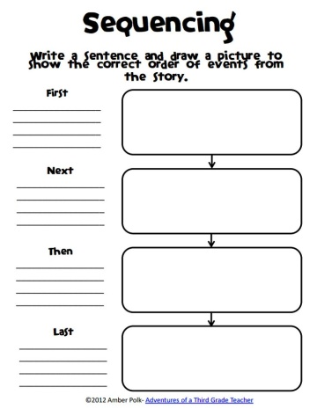 | Use subordinating (though, if , when, because etc.) to connect the sentences into one complex sentence.  - Deanne needs to learn English. Gianah will teach her.  - 2. It was drizzling outside. They went for a walk.  - Kyla needs to ask me. I will buy it for her.  - Keith played football extremely well. He was very young.  - Erik wants to get a new job. He is preparing for job interviews.
E. Discussing new concepts and practicing new skills #2 | Make new words by adding one of the given suffixes.  -ion, tion  1. create-_____________  2.expand-_____________  3.ascend-_____________  4.reduce-_____________  5.act-________________  6.promote-___________  7.isolta-_____________  8.donate-___________  9.evaporate-__________ | Group activity  Choose a part of the story that you can dramatize. Observe accuracy, appropriate expressions and correct pronunciation. Present your dramatization to the class. | Group activity  Using the following dependent clause make a compound –complex sentence.  - though you know the answer  - although he agrees with me  - how he found out  - while you work on the cake  - unless you can tell me
F. Developing Mastery  (Lead to Formative Assessment) | Complete the sentence by adding suffix tion/ion to the word in the inside theparentheses.  1.The police carried out an __________ into the crime.(investigate)  investigation  2.Joe had an __________ on his arm after he broke it.(opera  3.There was a lovely __________ on the cover of the book.(illustrate)  4.________speak louder than words.(act)  5. we were having a large _______built on the back of our.(extend). | Answer this questions:  - Do you think that the unfornate death of Thisbe and Pyramus could have been avoided if onbly both of them arrived at the agreed time?  - Do you think we can prevent these misfortunes from happening ? How? | Match the dependent clause with the right independent clause to form the compound –complex sentence. Then rewrite again the sentence.  Dependent clause  1.when the teacher asked him for it  2.because his cousin is allergic to poultry  3.after I swept the garage  Independent clause  a.I love eating turkey at Thanksgiving but my friend’s family eats lasagna  b.I asked my dad for my allowance but he only laughed at my request  c.Tom knew my name, but he forgot it. | Watch another video then identify what kind of propaganda .
G. Finding practical application of concepts and skills in daily living. | Group Activity  Use the following words in a sentence.  - Rotation  - Revolution  - Evaporation  - Eruption  - erosion | Recall the initial research tasks you have done in Lesson 36. Organize all notes and information you gathered following the outline below.  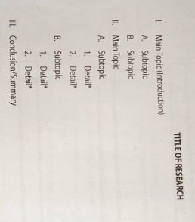 |  | Group Acitvity  Each group will present one of the kinds of propaganda.  - Name calling  - Glittering  - Bandwagon  - Plain folks  - testimonial
H. Making Generalization and Abstraction about the lesson | What are way in adding tion/ion to a root word?  Usually a verb is use as a base word . example:  Act-action deduce-deduction  Spelling tips for adding -tion/ion.  - If the verb ends in a T just add - ion  Example:  Diffract- diffraction  - Remove a final e gefore adding -tion  Example:  Intervene- intervention  - Sometimes you must add or remove a vowel before adding -tion  Example:  Add – addition (add i)  Register – registration (remove e)  Evolve - evolution
I. Evaluating Learning | Choose the letter of the correct answer.  1.Stop! You’re going in the wrong________.  a. director c. direction  b.direct d. direcssion  2. She lost all her ________ in a fire.  a.possesion c.possetion  b.possess d. possessor  3. I have enjoyed our ________but I really must do some work.  a.conversassion c.converse  b.conversation d.conversion  4. Traffic was diverted because of a _________ on the highway.  a.collission c. collition  b. collide d. collision  5.I get a great feeling of ________ when I complete all my work.  a.satisfaction c.satisfacssion  b.satisfy d.satisfacsion |  | Choose the correct conjunction to complete the compound-complex sentence.  1.I hate writing essays, ____I hate writing poetry, ______I love giving speeches.  a.but, because  b.so, when  c.for, before  d.and ,though  2. ______Bob got his license, he drove to school everyday____he picked me up.  a. after, and  b. before, because  c.while, though  d. unless, and  3.____you find a job, you should work during the summer,______you should cut back on your hours during the school year.  a. while, because  b. if, but  c. before, so  d. that, and  4.Ron is running for student council president,______ he will not win _____ he does not gret the seniors’ vote.  a. yet, while  b. for, before  c. but , if  d. and when  5._____my parents were at dinner, I cleaned the house_____my sister did the ironing.  a. before, so  b. after, if  c. although, for  d. while , and
J. Additional Activities for
Application or Remediation
IV. REMARKS
V. REFLECTION
A. No. of learners earned
80% in the evaluation
B. Number of learners who
are required additional activities for remediation who scored below 80%
C. Did the remedial lesson work? No. of learners who have caught up with the lesson
D. Number of learners who continue to require remediation
E. Which of my teaching strategies worked well? Why did these work?
F. What difficulties did I encounter which my principal or supervisor help me solve?
G. What innovation or localized materials/discover which I wish to share with other teachers?

