GRADES 1 to 12  DAILY LESSON LOG | School: |  | Grade Level: | VI
 | Teacher: |  | Learning Area: | MAPEH-HEALTH
 | Teaching Dates and Time: | MARCH 2 – MARCH 6, 2020 (WEEK 7) | Quarter: | 4TH QUARTER

 | MONDAY | TUESDAY | WEDNESDAY | THURSDAY | FRIDAY
I.OBJECTIVES
A.Content Standards | The learner understands the concepts and principles of selecting and using consumer health products | The learner understands the concepts and principles of selecting and using consumer health products | The learner understands the concepts and principles of selecting and using consumer health products | The learner understands the concepts and principles of selecting and using consumer health products Administering Weekly Test
B.Performance Standards | The learner consistently demonstrates critical thinking skills in the of health products. | The learner consistently demonstrates critical thinking skills in the of health products. | The learner consistently demonstrates critical thinking skills in the of health products. | The learner consistently demonstrates critical thinking skills in the of health products. - Administering test questions correctly - Administering of weekly test - Setting of standards - Test proper - Checking of test results
C.Learning Competencies/Objectives | Explains the uses of some over the counter and prescription medicines  H6CH-IVf-18 | Identifies the common propaganda techniques used in advertising  H6CH-IVg-19 | Identifies the common propaganda techniques used in advertising  H6CH-IVg-20 | Analyzes packaging and labels of health products  H6CH-IVh-21
II.CONTENT
III.LEARNING RESOURCES
A.References
1.Teacher’s Guide pages
2.Learners’s Materials pages | 21st Century Mapeh in Action 6 | 21st Century Mapeh in Action 6 | 21st Century Mapeh in Action 6 | 21st Century Mapeh in Action 6
3.Textbook pages | pp. 301-302 | pp. 302-303 | pp. 302-303 | pp. 303-304
4.Additional materials from learning resource (LR) portal
B.Other Learning Resource
IV.PROCEDURES
A.Reviewing previous lesson or presenting the new lesson |  | What is prescription medicine? | What is propaganda? | What is propaganda?
B.Establishing a purpose for the lesson | What is a medicine? | What is advertising? | Why do they use celebrities to endorse a product? | Read the label of a product.
C.Presenting Examples/ instances of the new lesson | What is a prescription medicine?  These are drugs that must be taken with a doctor’s supervision.  3 kinds of prescription medicines are:  1. Antibiotics  2. Antidepressant  3.Antihypertensives | Show an example of propaganda or advertising of a local product let the students identify the propaganda used.  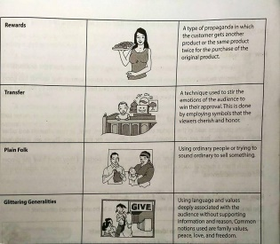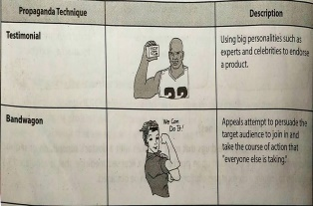 | Groupings.  Form 4 groups.  Each will imitate the common soap or detergent commercial on television. | Why reading product labes important?
D.Discussing new concepts and practicing new skills #1 | Why can’t we buy prescription medicines over the counter without a doctor’s prescription? | Examples of propaganda  - Testimonials  - Bandwagon  - Rewards  - Transfer  - Plain Folk  - Glitteering Generalities | What is the technique used in group 1? 2? 3? 4? | How can we have the best value for our money without reading product label?
E.Discussing new concepts and practicing new skills #2 | Show an example of prescription and analyse its contents. | Group Activity  Form 3 groups.  Each group will perform propaganda of a shampoo product. | How to be wise in choosing a product?  Original File Submitted and Formatted by DepEd Club Member - visit depedclub.com for more | How can we identify fake products?
F.Developing Mastery | What is prescription medicine? | What is propaganda was used in group 1? 2? 3? | What is the meaning of being “wais” | How can we be protected from fake products?  Study the tips below.  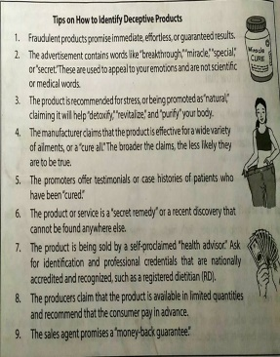
G.Finding Practical application of concepts and skills in daily living | Is it important to seek a doctor’s advice before taking any medication why? | Do we need to believe in all propaganda that we see or hear? Why?
H.Making generalization and abstraction about the lesson | What is a prescription medicine?  Give the three kinds of prescription medicines. | What is proganda?  Give its different techniques. | What is propaganda?  Enumerate the techniques used. | How important is it to read product labels?
I.Evaluating learning | What is a prescription medicine?  Give the three kinds of prescription medicine. | Put a check if it is a technique in propaganda.  - Advertisement  - Bandwagon  - Plain Folk  - Rewards  - Freebies | Give the techniques commonly used in propaganda. | Give tips on how to identify deceptive products.
J.additional activities for application or remediation

V.MGA TALA
VI.PAGNINILAY
A.Bilang ng mag-aaral na nakauha ng 80% sa pagtatayao.
B.Bilang ng mag-aaralna nangangailangan ng iba pang Gawain para sa remediation
C.Nakatulong ba ang remedial? Bilang ng mag-aaral na nakaunawa sa aralin.
D.Bilang ng mag-aaral na magpapatuloy sa remediation
E.Alin sa mga estratehiyang pagtuturo ang nakatulong ng lubos? Paano ito nakatulong?
F.Anong suliranin ang aking naranasan na solusyunansa tulong ng aking punungguro at superbisor?
G.Anong kagamitang panturo ang aking nadibuho nanais kong ibahagi sa kapwa ko guro?

