GRADES 1 to 12  DAILY LESSON LOG | School: |  | Grade Level: | II
 | Teacher: | Ma’am ESTRELLITA S. VINZON | Learning Area: | Math Q4 WEEK 8
 | Teaching Dates and Time: | March 2- 6, 2020 | Quarter: | 4TH QUARTER

OBJECTIVES | MONDAY | TUESDAY | WEDNESDAY | THURSDAY | FRIDAY
A. Content Standard | Demonstrates  understanding of time, standard measures of length, mass and capacity and area using square-tile units. | Demonstrates  understanding of time, standard measures of length, mass and capacity and area using square-tile units. | Demonstrates  understanding of time, standard measures of length, mass and capacity and area using square-tile units. | Demonstrates  understanding of time, standard measures of length, mass and capacity and area using square-tile units.
B. Performance  Standard | Is able to apply knowledge of time, standard measures of length, weight, and capacity, and area using square-tile units in mathematical problems and real-life situations. | Is able to apply knowledge of time, standard measures of length, weight, and capacity, and area using square-tile units in mathematical problems and real-life situations. | Is able to apply knowledge of time, standard measures of length, weight, and capacity, and area using square-tile units in mathematical problems and real-life situations. | Is able to apply knowledge of time, standard measures of length, weight, and capacity, and area using square-tile units in mathematical problems and real-life situations.
C. Learning  Competency/  Objectives  Write the LC code for each. | Identify appropriate unit of measure in finding the capacity  M2ME-IVf-33 | Collects data on one variable using a questionnaire.  M2SP-IVh-1.2  Sorts, classifies, and organizes data in tabular form and presents this into a pictograph without and with scales.  M2SP-IVi-2.2 | Infers and interprets data  presented in a pictograph  without and with scales.  M2SP-IVi-3.2 | Infers and interprets data  presented in a pictograph  without and with scales.  M2SP-IVi-3.2 | Summative Test
II. CONTENT | Lesson 113: Measuring capacity | Lesson 114: Collect and Organize Data | Lesson 115: Read and Make Pictograph | Lesson 115: Read and Make Pictograph
LEARNING RESOURCES
A. References | K-12 CGp.52 | K-12 CGp. | K-12 CGp. | K-12 CGp.
1. Teacher’s Guide pages | 374-377 | 397-400 | 401- 407 | 401- 407
2. Learner’s Materials pages | 264-266 | 281-284 | 284-286 | 284-286
3. Textbook pages
4. Additional Materials from Learning Resource (LR) portal
B. Other Learning Resource | 1. Bottles of soft drinks or medicines, cups, glasses and pitcher  2. Different items with different sizes with ml or l label content  3. Show Me Boards | 1. Non-transparent bag 3. Graphing paper  2. 20 crayons in red, blue, green and yellow (assorted number of each color) | 1. Calendar where Philippine holidays are written  2. Sample Pictographs | 1. Calendar where Philippine holidays are written  2. Sample Pictographs
III. PROCEDURES
A. Reviewing previous lesson or presenting the new lesson | Show the different measuring device. Ask:  c. Can you remember how you use these things when you were in Grade 1?  d. How many glasses of water are there in a pitcher?  e. Can you still remember the number of bottles of mineral water in a bottle of family-sized soft drink? | Show to the pupils an empty non-transparent bag. (or use a covered  jar) Put all the 20 crayons in the bag. Explain to the pupils that they are going to use the crayons to make a graph that shows how many are there in each color. Ask the pupils to create a graph of the colors of the crayons.  (similar to the one below using their graphing paper) At random, ask pupil/s to draw/pick a crayon and then color the rectangle above the line in the column for that color. Put the crayons back in the bag. Have the pupil repeat this process with each of the crayons, coloring each new rectangle directly above the last rectangle of that color. | Show a calendar where all regular holidays in every month are listed.  Select the first 4 months of the calendar and count the number of holidays.( | Show a calendar where all regular holidays in every month are listed.  Select the first 4 months of the calendar and count the number of holidays.(
B. Establishing a purpose for the  Lesson | 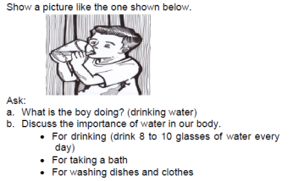 | 1. Motivation  Ask: Which crayons are most often drew/picked? How can you tell?  Which are the least of? How can you tell?  Are there any colors tied or equal number of draws?  What does the graph tell you? Why? | 1.Motivation  What tree is abundant in your place? (Coconut, Mango, etc.)  Have you seen a coconut tree (most common)?  What can we get from a coconut tree? | 1.Motivation  What tree is abundant in your place? (Coconut, Mango, etc.)  Have you seen a coconut tree (most common)?  What can we get from a coconut tree?
C. Presenting examples/ instances of the new lesson | Present the lesson using  - Concrete  - Pictorial  - abstract | Let the pupils collect stones or leaves according to different categories such as big/small, round/flat, smooth/rough, light/heavy, shiny/dark, etc. Count the number of pupils who brought big/small stones or leaves (with respect to categories) and record/write the data gathered in the worksheet (refer to sample worksheet: on the board or individually in a sheet of paper.)  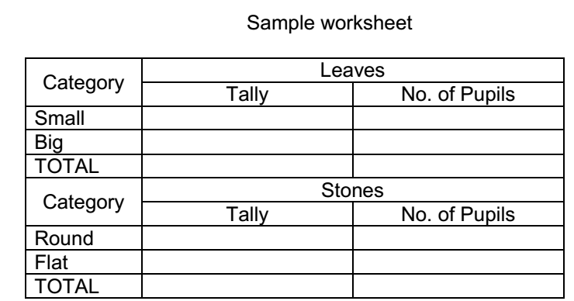  How many pupils brought (categories) stones/leaves?  What is the least common category?  What is the most common category?  What is the total number of pupils? | Today we will make a pictograph. What is a pictograph? A  pictograph is a graph that uses pictures or symbols to show or represent data. All pictographs have labels and Key or legend. A label is a short description  given for the purpose of identification. A key or legend is a word or phrase or number written on or next to a picture, map, etc. that explains what it is about or what the symbols on it mean or equal to.  Conduct a survey to the class who have old or new bags, shoes, hats and umbrellas, etc. (anything that the pupils usually bring to school) Group the pupils according to the classification s/he sets. Write on the board or uselarge chart paper, or an overhead projector to record the information in a tally chart format. Let the pupils draw the categories if possible. From the collected data, let them create their own data representations or even their own pictograph. S/he should see to it (observe/guide) that the pupils include the necessary parts of the graph/table.  include the necessary parts of the graph/table. | Today we will make a pictograph. What is a pictograph? A  pictograph is a graph that uses pictures or symbols to show or represent data. All pictographs have labels and Key or legend. A label is a short description  given for the purpose of identification. A key or legend is a word or phrase or number written on or next to a picture, map, etc. that explains what it is about or what the symbols on it mean or equal to.  Conduct a survey to the class who have old or new bags, shoes, hats and umbrellas, etc. (anything that the pupils usually bring to school) Group the pupils according to the classification s/he sets. Write on the board or uselarge chart paper, or an overhead projector to record the information in a tally chart format. Let the pupils draw the categories if possible. From the collected data, let them create their own data representations or even their own pictograph. S/he should see to it (observe/guide) that the pupils include the necessary parts of the graph/table.  include the necessary parts of the graph/table.
D. Discussing new concepts and practicing new skills #1 | Divide the class into three’s. Using their Show Me Boards, let each group write if the capacity inside the container will be measured by liter or milliliter.  1. Water inside a tank  2. Juice inside a small can  3. Milk in a glass  4. Water in a gallon  5. Vinegar in a sachet  Ask the pupils to present their answers in front of the class. | What are the food choices of the class?  Which among the foods got the highest votes?  Which among the foods got the lowest votes?  What is the total number of votes?  Based on the result, what are the two foods preferred by the class to  have in the party?  Answers will vary.  How many pupils ride a school bus?  How many pupils walk to school?  How many pupils ride a car from home?  How many pupils ride on their bike?  What means of transportation do most pupils used?  . | What is the title of the Pictograph? Who has a big lot? What are the labels in the pictograph? What is the symbol used in the pictograph?  What did he want to plant on it? How many months did he plant?  Let the pupils read the months. What is the key or legend of the pictograph?  What is the equivalent of one  ? (How many coconut tree a picture  represents?)  What month did he plant the most number of coconut trees?  (If 1 coconut tree (picture) | What is the title of the Pictograph? Who has a big lot? What are the labels in the pictograph? What is the symbol used in the pictograph?  What did he want to plant on it? How many months did he plant?  Let the pupils read the months. What is the key or legend of the pictograph?  What is the equivalent of one  ? (How many coconut tree a picture  represents?)  What month did he plant the most number of coconut trees?  (If 1 coconut tree (picture)
E. Discussing new concepts and practicing new skills #2 | 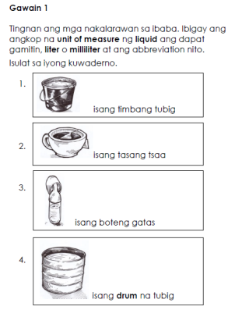 | Sa anong paraan/sasakyan ka nakararating sa  paaralan? Gamitin ang datos na nakasaad sa talakayan  upang makagawa ng pictograph.  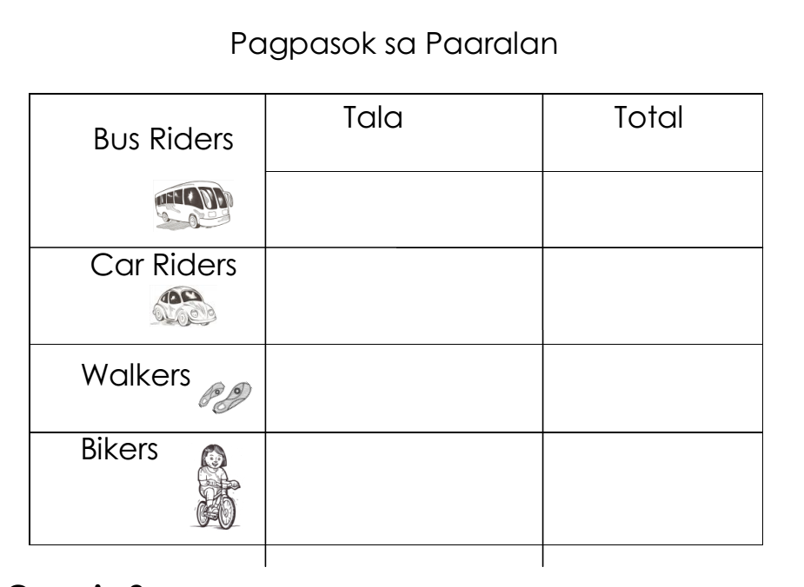 | Makikita sa larawan ang tala ng mga Boy Scouts na  nakilahok sa programang “Barangay Clean Up” sa  loob ng isang linggo.  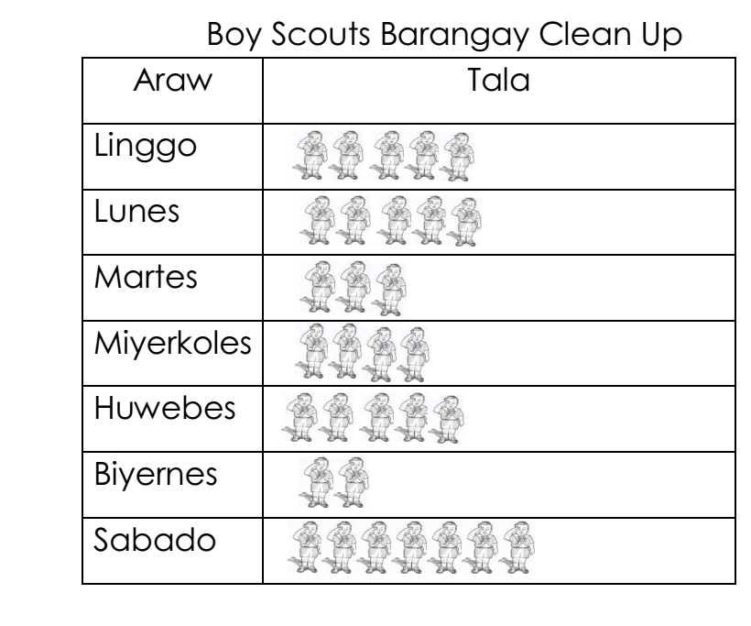 | Makikita sa larawan ang tala ng mga Boy Scouts na  nakilahok sa programang “Barangay Clean Up” sa  loob ng isang linggo.
F. Developing mastery (leads to Formative Assessment 3) | Anong unit of capacity ang gagamitin sa mga sumusunod na aytem? Isulat ang liter o meliliter at ang abbreviation nito.  - Isang galong tubig  - Isang tasang tsaa  - Pitsel na coke  - Basong juice  - Boteng mantika | Basahin ang kuwento at sagutin ang mga tanong.  SPED Day Out Kaarawan ni Teacher Vicky. Inanyayahan niya ang kanyang mga mag-aaral na kumain sa malapit na Ice Cream House. Nakasulat sa menu ang flavorsna kanilang maaaring bilhin. Lima ang maaari nilang pagpilian: Triple Chocolate, Cookies ‘nCream, Rocky Road, Double Dutch and Ube Macapuno. Pinili ni Ronnie ay Triple Chocolate. Ube Macapuno naman ang kay Amanda. Sina Gino at Gina ay Rocky Road at ganoon din ang kina Junnie at Maya. Ang gusto ni Mario ay Double Dutch  samantalang Rocky Road naman ang gusto ni  Nenita. Pagkatapos nilang pumili, silang lahat ay  pumila upang kunin ang nagustuhang ice cream.  Masaya silang lahat na kumain.  Ilagay ang tamang bilang ng mga datos sa grid.  Kumpletuhin ito.  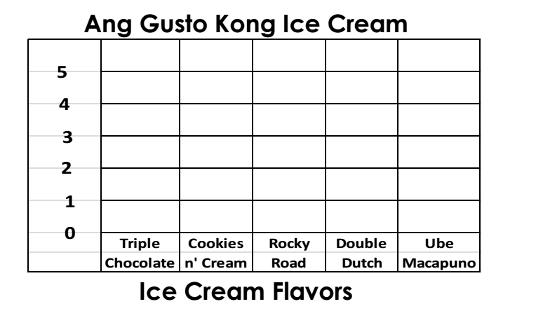 | Gumawa ng Tally Chart ayon sa pictograph sa  ibaba.  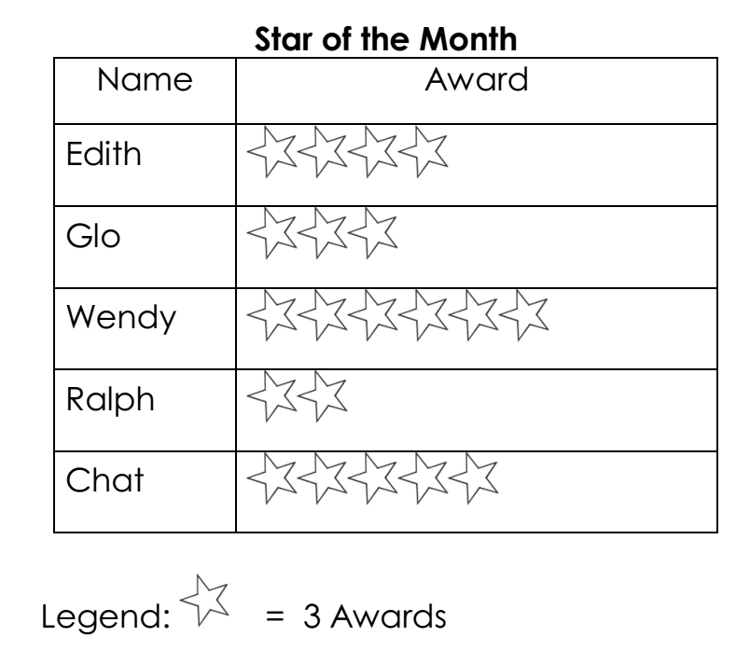 | Gumawa ng Tally Chart ayon sa pictograph sa  ibaba.
G. Finding practical application of concepts and skills in daily living | 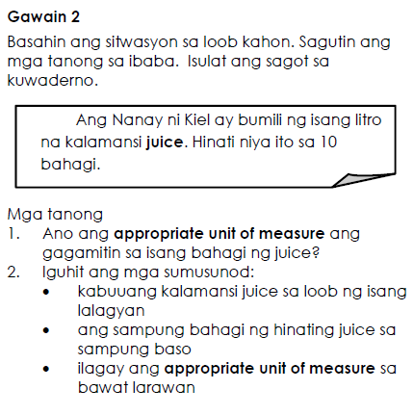 | Nais malaman ni Nikky kung ano at ilan ang alagang hayop ng kanyang mga kaklase. Gusto rin niyang  malaman kung ilan ang walang alagang hayop.  Nakasulat sa ibaba ang tala ng mga ito.  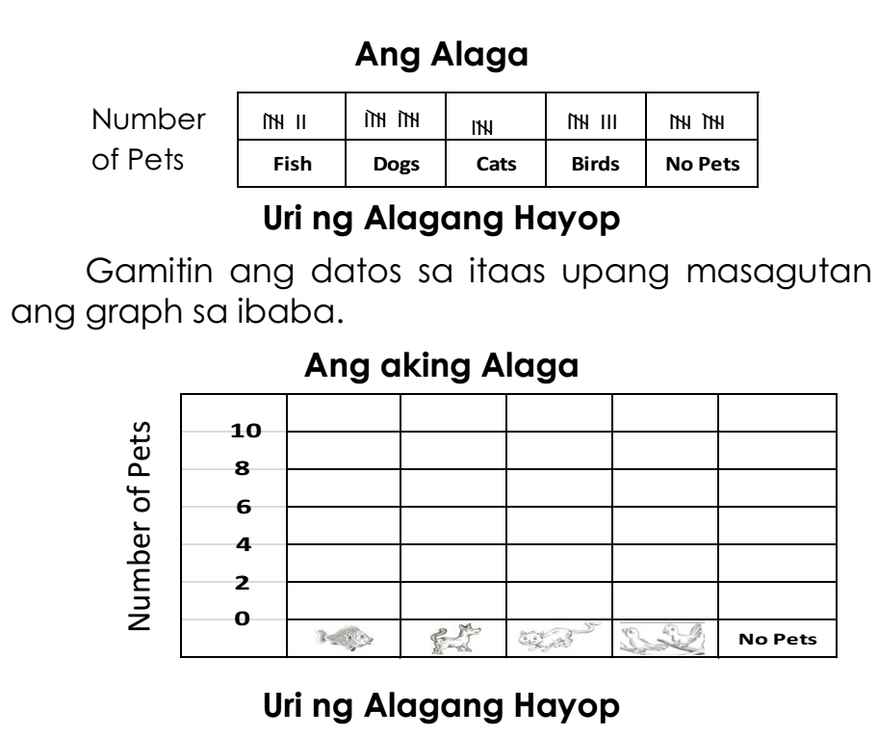 | Isulat sa papel ang sagot sa ipinakitang tally chart. | Isulat sa papel ang sagot sa ipinakitang tally chart. | Show honesty in answering the test questions
H.Making generalizations  and abstractions about the lesson | The capacity of liquid is measured in liter when in big amount and in mililiter when in small amount. | Data are information that are collected about people or things  Tally Chart is a chart that uses tally marks to show data. | What is a pictograph?  It is a representation of data using pictures.  What is a key or legend?  It is a short description of a picture or illustration.  How can we interpret a pictograph?  We can interpret a pictograph by using legend. | What is a pictograph?  It is a representation of data using pictures.  What is a key or legend?  It is a short description of a picture or illustration.  How can we interpret a pictograph?  We can interpret a pictograph by using legend.
I. Evaluating learning | Anong unit of capacity ang gagamitin sa mga sumusunod na aytem? Isulat ang liter o meliliter at ang abbreviation nito.  1. Tubig sa loob ng tangke  2. Gatas sa tasa  3. Tubig sa pitsel  4. Suka sa bote  5. Juice sa baso | The students of Holy Infant Academy are voting for the booth they want to have at the Academy Day. They wanted to know the booth preferred by the students. The results of the voting survey are as follows:  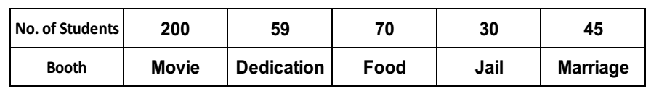  Make a picture graph using the above data. | 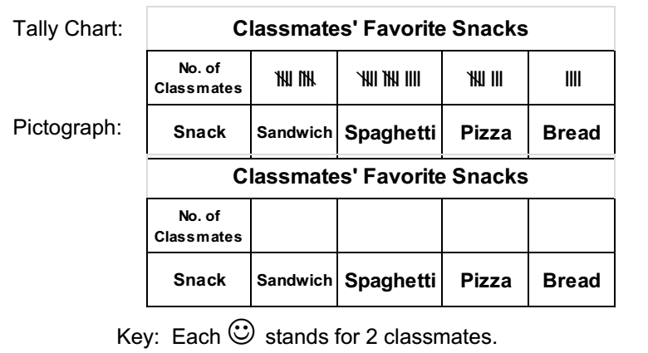  1. What is the most favorite snack of the pupils?  2. What is the least favorite snack?  3. How many pupils like sandwich? Spaghetti? Pizza? Bread?  4. How many pupils like spaghetti and bread?  5. What is the total number of pupils? | 1. What is the most favorite snack of the pupils?  2. What is the least favorite snack?  3. How many pupils like sandwich? Spaghetti? Pizza? Bread?  4. How many pupils like spaghetti and bread?  5. What is the total number of pupils? | Recording the test resulte
J. Additional activities for application or remediation | Isulat sa kuwaderno ang mga liquid items sa inyong bahay na ang laman ay sinusukat sa liter at milliliter. Humingi ng tulong sa nakatatanda. | Kumpletuhin ang table ayon sa talang ibinigay.  Gawin sa kuwaderno.  Paboritong prutas ng mga bata: | Ang sumusunod ay talaan ng mga miyembro ng HIA Sports Club. Gumawa ng pictograph gamit ang  talaang ito. Isulat sa papel ang iyong kasagutan.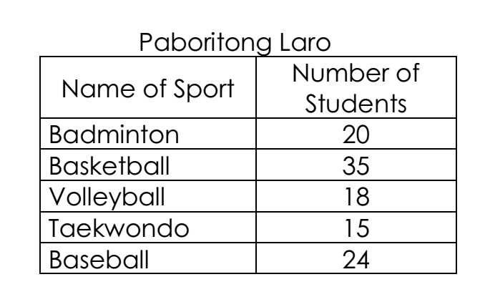 | Ang sumusunod ay talaan ng mga miyembro ng HIA Sports Club. Gumawa ng pictograph gamit ang  talaang ito. Isulat sa papel ang iyong kasagutan.
IV. REMARKS
V. REFLECTION
A..No. of learners who earned 80% in the evaluation
B.No. of learners
who require additional activities for remediation who scored below 80%
C. Did the remedial lessons work?
No. of learners who have caught up with
the lesson
D. No. of learners who continue to require remediation
E. Which of my teachingstrategies worked well? Why did these work? | Strategies used that work well:  ___ Group collaboration  ___ Games  ___ Solving Puzzles/Jigsaw  ___ Answering preliminary  activities/exercises  ___ Carousel  ___ Diads  ___ Think-Pair-Share (TPS)  ___ Rereading of Paragraphs/  Poems/Stories  ___ Differentiated Instruction  ___ Role Playing/Drama  ___ Discovery Method  ___ Lecture MethodWhy?  ___ Complete IMs  ___ Availability of Materials  ___ Pupils’ eagerness to learn  ___ Group member’s Cooperation in  doing their tasks | Strategies used that work well:  ___ Group collaboration  ___ Games  ___ Solving Puzzles/Jigsaw  ___ Answering preliminary  activities/exercises  ___ Carousel  ___ Diads  ___ Think-Pair-Share (TPS)  ___ Rereading of Paragraphs/  Poems/Stories  ___ Differentiated Instruction  ___ Role Playing/Drama  ___ Discovery Method  ___ Lecture MethodWhy?  ___ Complete IMs  ___ Availability of Materials  ___ Pupils’ eagerness to learn  ___ Group member’s Cooperation in  doing their tasks | Strategies used that work well:  ___ Group collaboration  ___ Games  ___ Solving Puzzles/Jigsaw  ___ Answering preliminary  activities/exercises  ___ Carousel  ___ Diads  ___ Think-Pair-Share (TPS)  ___ Rereading of Paragraphs/  Poems/Stories  ___ Differentiated Instruction  ___ Role Playing/Drama  ___ Discovery Method  ___ Lecture MethodWhy?  ___ Complete IMs  ___ Availability of Materials  ___ Pupils’ eagerness to learn  ___ Group member’s Cooperation in  doing their tasks
F. Whatdifficulties did I encounter which my principal or supervisor can help me solve? | __ Bullying among pupils  __ Pupils’ behavior/attitude  __ Colorful IMs  __ Unavailable Technology  Equipment (AVR/LCD)  __ Science/ Computer/  Internet Lab  __ Additional Clerical works | __ Bullying among pupils  __ Pupils’ behavior/attitude  __ Colorful IMs  __ Unavailable Technology  Equipment (AVR/LCD)  __ Science/ Computer/  Internet Lab  __ Additional Clerical works | __ Bullying among pupils  __ Pupils’ behavior/attitude  __ Colorful IMs  __ Unavailable Technology  Equipment (AVR/LCD)  __ Science/ Computer/  Internet Lab  __ Additional Clerical works
G. What innovation or localized materials did I use/discover which I wish to share with other teachers? | Planned Innovations:  __ Localized Videos  __ Making big books from  views of the locality  __ Recycling of plastics to be used as Instructional Materials  __ local poetical composition | Planned Innovations:  __ Localized Videos  __ Making big books from  views of the locality  __ Recycling of plastics to be used as Instructional Materials  __ local poetical composition | Planned Innovations:  __ Localized Videos  __ Making big books from  views of the locality  __ Recycling of plastics to be used as Instructional Materials  __ local poetical composition

