GRADES 1 to 12  DAILY LESSON LOG | School: |  | Grade Level: | IV
 | Teacher: | File created by Sir BIENVINIDO C. CRUZ JR | Learning Area: | ENGLISH
 | Teaching Dates and Time: | MARCH 9 – 13, 2020 (WEEK 8) | Quarter: | 4th QUARTER

 | MONDAY |  | TUESDAY |  | WEDNESDAY |  |  | THURSDAY | FRIDAY
I. OBJECTIVES
A. CONTENT STANDARDS |  | OL – The learner demonstrates understanding of verbal cues for clear expression of ideas  LC – the learner demonstrates an understanding of the elements of literary and informational texts for comprehension |  | V - The learner demonstrates an understanding that word meaning can be derived from different sources  The learner demonstrates an understanding that words are composed of different parts and their meaning changes depending on context  A – The learner demonstrates an understanding of verbal and nonverbal elements of communication to respond back |  | RC –The learner demonstrates understanding of various linguistics nodes to comprehend various texts  ORF – The learner demonstrates an understanding that English is stress-timed language to achieve accuracy and automaticity | SS – The learner demonstrates an understanding of library skills to research on a variety of topics |  | G – The learner demonstrates a command of the conventions of standard English grammar and usage when writing or speaking  WC – the learner demonstrates an understanding of the importance of using varied sources of information to support writing
B. PERFORMANCE STANDARDS |  | OL – The learner efficiently delivers oral presentations  LC – The learner identifies story perspectives and text elements |  | V – The learner uses different resources to find word meaning  The learner uses strategies to decode the meaning of words  A – The learner uses paralanguage and nonverbal cues to respond appropriately |  | RC – The learner uses knowledge of text types to correctly distinguish literary from informational text  ORF- The learner reads aloud text with accuracy, automaticity, and prosody | SS – The learner uses library skills to gather appropriate and relevant information |  | G – The learner speaks and writes using good command of the conventions of standard  WC- The learner uses varied sources of information to support writing
C. LEARNING COMPETENCIES/  OBJECTIVES (Write the LC Code for each) |  | LC – Identify cause-and-effect relationship  EN4LC-IVh-2.16  OL – State the effects of a given cause  EN4OL-IVh-27 |  | V- Identify meaning of words with suffixes –ly and -y  EN4V-IVh-46  A-Browse and read books for learning or for pleasure  EN4A-IVh-32 |  | RC- Identify cause-and-effect relationship  EN4RC-IVh-2.16  ORF- Read grade-level texts with 118 words correct words per minute EN4F-IVh- 1.13 | SS- Use a glossary to get the meaning of words EN4G-IVh-21 |  | G – Use simple sentence: simple subject + compound predicate  EN4G-IVh-24  WC-Write 5 – 6 sentence paragraph about a given topic (Publishing)  EN4WC-IVh-41
II. CONTENT
 |  | - Identifying Cause-and-Effect Relationship  -Stating the Effects of a Given Cause |  | -Identifying Meaning of Words with Suffixes –ly and –y  -Browsing and Reading Books for Learning or for Pleasure |  | - Identifying Cause and Effect Relationship  -Reading Grade-Level Texts with 118 Words Correct Words per Minute | -Using a Glossary to Get the Meaning of Words |  | - Using Simple Sentence  -Writing 5-6 Sentence Paragraph About a Given Topic (Publishing)
LEARNING RESOURCES
A. References
1. Teacher’s Guide Pages |  | TG pp. 244- 248 |  | TG p. 434 - 435 |  | TG pp. 244 - 248 | TG pp. 374 - 375 |  | TG pp.428 - 429
2. Learner’s Materials Pages |  | LM pp. 258-262 |  | LM pp. 421-423 |  | LM pp.258 - 262 | LM p.274, 361 - 365 |  | LM pp. 417
3. Textbook Pages |  | Soaring High With Reading 4
4. Additional Materials from Learning
Resource (LR) Portal
B. Other Learning Resources |  | Pictures, Chart, PPTx, foldables, text for generalizarion |  | Pictures, Chart, PPT, task cards, foldables, dictionary |  | Pictures, Chart, PPTx, foldables | Pictures, Chart, PPTx, foldables, dictionary or book with glossary |  | Chart, PPTx, foldables
III. PROCEDURES
A. Reviewing the previous lesson or presenting the new lesson |  | Do you have dreams in your life? What is your dream when you grow up? Call pupils to answer. |  | Let the pupils read the words that the teacher will flash.  Orderly properly meaningfully  Gracefully carefully easily  Rainy sunny cloudy breezy etc. |  | Do you have dreams in your life? What is your dream when you grow up? Call pupils to answer. | Do you know what a glossary is? Where can you find a glossary? In what part of the book? |  | Recall about simple sentences with simple subject and simple predicate.  Let the pupils make their own sentences with compound subjects and simple predicate.
B. Establishing a purpose for the lesson |  | How did Eduardo intend to become rich? Tell: We will find out in the story the teacher will tell. |  | Ask: What did you notice about the group of words? How do they end? What letters are added to the root words?  Original File Submitted and Formatted by DepEd Club Member - visit depedclub.com for more |  | How did Eduardo intend to become rich? Tell: We will find out in the story that we are going to read. | A glossary is a small dictionary usually found at the back of the book. It gives the meaning and pronunciation of words used in the selection. These are entry words which are alphabetically arranged. |  | 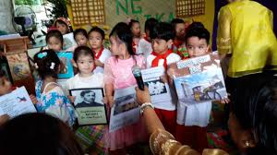  Show pictures to class. Ask: Can you make sentences using simple subject and compound predicate?  The children are reading and standing in class.  The members of the group are singing and standing in the room.
C. Presenting examples/instances of the new lesson |  | Unlocking of difficulties  Basi spilled over dream  Let the pupils listen the teacher will read. EDUARDO’S DREAM on LM p. 258 |  | Present the words on LM p. 421 Find Out and Learn  What o you notice about the words?  What kind of words are in the first box? Second box? |  | Unlocking of difficulties  Basi spilled over dream  Let the pupils read the story. EDUARDO’S DREAM on LM p. 258 | Present a glossary to pupils.  advertisement(ad’ver tiz mant)- a public notice to call attention to a product  aft(aft)- the rear of a ship  aspen (as,pen)- a type of popular tree  audience (o,deans)- a formal meeting with people |  | Present sentences to class.  The pupils are dancing and singing in the program.  Which is the simple subject?  Which is the compound predicate?
D. Discussing new concepts and practicing new skills #1 |  | Let the pupils answer the questions on LM p. 259. Talk About It. ( 1 – 6 )  Discuss about cause and effect relationship.  The cause brings out an event called its result. The result is also called an effect.  The cause effect relationship describes something that happens and why it happens.  The cause is the reason and the effect is the result of an event. |  | Let the pupils notice that the first group of words ends in –ly and the second group of words ends in –y. The letters –ly and –y are suffixes.  Explain to pupils that the root words in the first column are adjectives. By adding –ly the adjectives become adverbs.  The root words in the second column are nouns. By adding –y, the nouns becomes adjectives. |  | Let the pupils answer the questions on LM p. 259. Talk About It. ( 1 – 6 )  Discuss about cause and effect relationship.  The cause brings out an event called its result. The result is also called an effect.  The cause effect relationship describes something that happens and why it happens.  The cause is the reason and the effect is the result of an event. | Where can you see an aft?  To whom do you address your speech?  What do you call someone great?  When you place a commercial, what do you call such?  Can you name an example of popular tree? |  | Discussion about simple sentences with simple subject and compound predicate.  Tell the pupils that these sentences can be used in writing a paragraph about a certain topic.
E. Discussing new concepts and practicing new skills #2 |  | Guided Practice  Get a partner and ask the following questions. Let the pupils listen to the teacher.  Why do you go to school?  Why do you take a bath every day?  Why do you water the plants?  Why do you wear warm clothes during the month of December?  Why do you stay at home during a typhoon? |  | Guided Practice  Let the group answer the following.  Group I – what can you do easily?  Group II – what can you do patiently?  Group III –what can you do loudly?  Group IV – what can you do slowly?  Group V – what can you do clearly?  Refer to LM p. 423. |  | Guided Practice  Get a partner and ask the following questions. Let the pupils listen to the teacher.  Why do you go to school?  Why do you take a bath every day?  Why do you water the plants?  Why do you wear warm clothes during the month of December?  Why do you stay at home during a typhoon? | Guided Practice  Let the group do the following.  Group I – Do Find Out and Learn on LM p. 361  Group II – Do Try and Learn. Refer to LM p. 362 ( 1 – 5 ).  Group III- Refer to LM pp. 364 – 365 ( 1 – 10 ) |  | Guided Practice  Each group will write a paragraph using simple sentences with simple subjects and compound predicate.  Group I – write about your favorite pet  Group II – your unforgettable trip  Group III – your precious gift from a friend  Group IV – your hobbies
F. Developing mastery  (Leads to Formative Assessment 3) |  | Independent Practice  Look at each pair of pictures. Say something about them. Identify the cause and the effect.  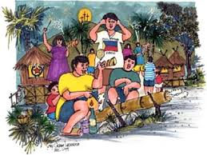  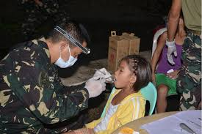  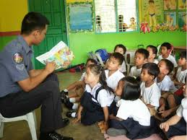 |  | Independent Practice  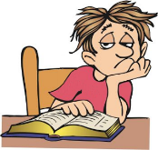  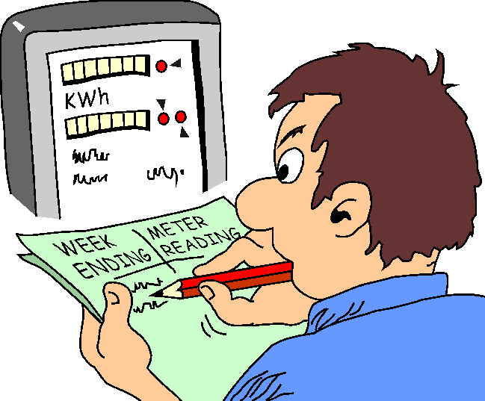  Use the following in sentences. Be guided with the pictures  Sadly  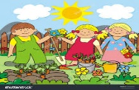  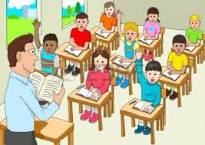  attentively  sunny |  | Independent Practice  Let the pupils do Find Out and Learn on LM pp. 259 – 260.  Look at each pair of pictures. Say something about them. Identify the cause and the effect. ( 1 – 5 ) | Independent Practice  This is a glossary. Answer the questions afterwards.  echo – a sound wave that is reflected when it hits a high obstacle such as hill  erosion – the process by which the uppermost part of the soil is washed away by wind or water  fertilized egg- a very small cell in the mother’s womb from which a baby develops  fog – a cloud that lie near the ground  friction- the rubbing of two things together which produces heat  Which word will produce heat and fire?  What do you mean by echo?  What is a fertilized egg?  What is a cloud that lie near the ground? |  | Independent Practice  Let the pupils do Learn Some More on LM p. 417. Use simple sentences with simple subject and compound predicate.
G. Finding practical application of concepts and skills in daily living |  | Listen to this.  Andrew got perfect score in the test because he studied his lessons very well.  Which is the cause/ Which is the effect? |  | Use the following words in  Sentences.  Sunny  Gloomy  Patiently  Religiously  Chilly  stormy |  | Read the situation.  The children must eat nutritious foods every day so that they will become strong and healthy.  Which is the cause? Which is the effect?  Let the pupils do Learn Some More on LM p. 262 ( 1 – 5 ) | Do this in pairs.  fax- n. facsimile; a machine used to send or receive facsimile communication  fierce –adj. Violently hostile or aggressive in temperament, given to fighting or killing  fossil- n. Remnants; traces or remains of organisms in the past  glisten- v. To give off sparkling reaction  What term refers to the remains in the past?  What do you mean by fierce?  What is used to receive facsimile? |  | Make a paragraph using simple subject and compound predicate.  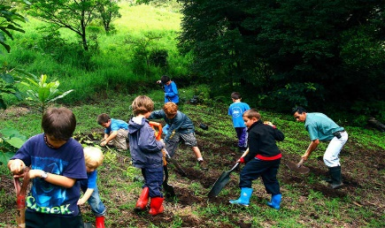  The picture will guide you.  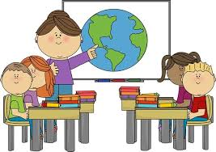
H. Making generalizations of concepts and skills in daily living |  | The cause is an action or an event that makes something happen. An effect is something that happens as a result of the action.  Cause is the reason and the effect is the result of an event. A cause-effect relationship describes something that happens and why it happens.. |  | The root words like slow, quick, loud are adjectives. By adding –ly, the adjectives become adverbs (these indicate how an action happened or is done.  The root words like chill, fog, mist are nouns. By adding –y, the nouns becomes adjectives (these indicate having or like something). |  | The cause is an action or an event that makes something happen. An effect is something that happens as a result of the action.  Cause is the reason and the effect is the result of an event. A cause-effect relationship describes something that happens and why it happens.. | The glossary is a part of a book which lists key words found in the book.  The entry word in a glossary are arranged in alphabetical order. Some glossaries include the pronunciation of words.  It is usually found on the last page of a book. |  | If a sentence is composed of a simple subject and a simple predicate, it is called a SIMPLE SENTENCE.  If there are two subjects, it is called a compound subject.  If there is a compound subject and simple predicate, it is still a SIMPLE SENTENCE.
I. Evaluating learning |  | Directions: Listen to the statements the teacher will read then supply the missing phrases to complete the thought.  1.The audience could not hear the message of the speaker because_________________.  2. the group of girls finished their task in 30 minutes because________________.  3._______________ because she ate a lot of chocolates.  4. _______________ so the teacher will be very happy.  5. the school ground is clean because _________________. |  | Directions: Read each sentence. Choose from the box the correct word to complete the sentences.  Refer to LM p. 422.  ( 1 – 5 ) |  | Directions: Complete the following sentences by writing the letter of the correct cause for each effect. Refer to LM pp. 261 – 262 ( 1 – 5 ) | Directions: Read the glossary entry. Answer the questions that follow.  attendant-n. waiter; servant  brigade- n. subdivision of army  exile – v. expel; deport  implement- v. carry out  limb- n. a large branch of a tree  1. What is the first word in the list?  2. How many definitions were given for the word exile?  3. What does implement mean?  4. What word means a large branch of a tree?  5. How many syllables are there in the word “limb”? |  | 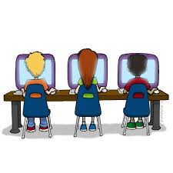  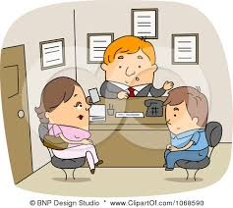  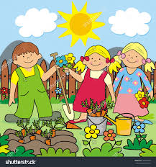  Directions: Look at the pictures below. Use simple subject and a compound predicate for the pictures.
J. Additional activities for application
V.REMARKS
 | VI.REFLECTION
No. of learners who earned 80% in the evaluation |  | ___ of Learners who earned 80% above | ___ of Learners who earned 80% above | ___ of Learners who earned 80% above | ___ of Learners who earned 80% above | ___ of Learners who earned 80% above
No. of learners who require additional activities for remediation who scored below 80% |  | ___ of Learners who require additional activities for remediation | ___ of Learners who require additional activities for remediation | ___ of Learners who require additional activities for remediation | ___ of Learners who require additional activities for remediation | ___ of Learners who require additional activities for remediation
Did the remedial lessons work? No. of learners who have caught up with the lesson |  | ___Yes ___No  ____ of Learners who caught up the lesson | ___Yes ___No  ____ of Learners who caught up the lesson | ___Yes ___No  ____ of Learners who caught up the lesson | ___Yes ___No  ____ of Learners who caught up the lesson | ___Yes ___No  ____ of Learners who caught up the lesson
No. of learners who continue to require remediation |  | ___ of Learners who continue to require remediation | ___ of Learners who continue to require remediation | ___ of Learners who continue to require remediation | ___ of Learners who continue to require remediation | ___ of Learners who continue to require remediation
Which of my teaching strategies worked well? Why did these work? |  | Strategies used that work well:  ___ Group collaboration  ___ Games  ___ Power Point Presentation  ___ Answering preliminary  activities/exercises  ___ Discussion  ___ Case Method  ___ Think-Pair-Share (TPS)  ___ Rereading of Paragraphs/  Poems/Stories  ___ Differentiated Instruction  ___ Role Playing/Drama  ___ Discovery Method  ___ Lecture Method Why?  ___ Complete IMs  ___ Availability of Materials  ___ Pupils’ eagerness to learn  ___ Group member’s Cooperation in doing their tasks | Strategies used that work well:  ___ Group collaboration  ___ Games  ___ Power Point Presentation  ___ Answering preliminary  activities/exercises  ___ Discussion  ___ Case Method  ___ Think-Pair-Share (TPS)  ___ Rereading of Paragraphs/  Poems/Stories  ___ Differentiated Instruction  ___ Role Playing/Drama  ___ Discovery Method  ___ Lecture Method Why?  ___ Complete IMs  ___ Availability of Materials  ___ Pupils’ eagerness to learn  ___ Group member’s  Cooperation in doing their tasks | Strategies used that work well:  ___ Group collaboration  ___ Games  ___ Power Point Presentation  ___ Answering preliminary  activities/exercises  ___ Discussion  ___ Case Method  ___ Think-Pair-Share (TPS)  ___ Rereading of Paragraphs/  Poems/Stories  ___ Differentiated Instruction  ___ Role Playing/Drama  ___ Discovery Method  ___ Lecture Method Why?  ___ Complete IMs  ___ Availability of Materials  ___ Pupils’ eagerness to learn  ___ Group member’s  Cooperation in doing their tasks | Strategies used that work well:  ___ Group collaboration  ___ Games  ___ Power Point Presentation  ___ Answering preliminary  activities/exercises  ___ Discussion  ___ Case Method  ___ Think-Pair-Share (TPS)  ___ Rereading of Paragraphs/  Poems/Stories  ___ Differentiated Instruction  ___ Role Playing/Drama  ___ Discovery Method  ___ Lecture Method Why?  ___ Complete IMs  ___ Availability of Materials  ___ Pupils’ eagerness to learn  ___ Group member’s  Cooperation in doing their tasks | Strategies used that work well:  ___ Group collaboration  ___ Games  ___ Power Point Presentation  ___ Answering preliminary  activities/exercises  ___ Discussion  ___ Case Method  ___ Think-Pair-Share (TPS)  ___ Rereading of Paragraphs/  Poems/Stories  ___ Differentiated Instruction  ___ Role Playing/Drama  ___ Discovery Method  ___ Lecture Method Why?  ___ Complete IMs  ___ Availability of Materials  ___ Pupils’ eagerness to learn  ___ Group member’s  Cooperation in doing their tasks
What difficulties did I encounter which my principal or supervisor can help me solve? |  | __ Bullying among pupils  __ Pupils’ behavior/attitude  __ Colorful IMs  __ Unavailable Technology  Equipment (AVR/LCD)  __ Science/ Computer/  Internet Lab  __ Additional Clerical works  __Reading Readiness  __Lack of Interest of pupils | __ Bullying among pupils  __ Pupils’ behavior/attitude  __ Colorful IMs  __ Unavailable Technology  Equipment (AVR/LCD)  __ Science/ Computer/  Internet Lab  __ Additional Clerical works  __Reading Readiness  __Lack of Interest of pupils | __ Bullying among pupils  __ Pupils’ behavior/attitude  __ Colorful IMs  __ Unavailable Technology  Equipment (AVR/LCD)  __ Science/ Computer/  Internet Lab  __ Additional Clerical works  __Reading Readiness  __Lack of Interest of pupils | __ Bullying among pupils  __ Pupils’ behavior/attitude  __ Colorful IMs  __ Unavailable Technology  Equipment (AVR/LCD)  __ Science/ Computer/  Internet Lab  __ Additional Clerical works  __Reading Readiness  __Lack of Interest of pupils | __ Bullying among pupils  __ Pupils’ behavior/attitude  __ Colorful IMs  __ Unavailable Technology  Equipment (AVR/LCD)  __ Science/ Computer/  Internet Lab  __ Additional Clerical works  __Reading Readiness  __Lack of Interest of pupils
What innovation or localized materials did I use/discover which I wish to share with other teachers? |  | Planned Innovations:  __ Localized Videos  __ Making use big books from  views of the locality  __ Recycling of plastics to be used as Instructional Materials  __ local poetical composition  __Fashcards  __Pictures | Planned Innovations:  __ Localized Videos  __ Making use big books from  views of the locality  __ Recycling of plastics to be used as Instructional Materials  __ local poetical composition  __Fashcards  __Pictures | Planned Innovations:  __ Localized Videos  __ Making use big books from  views of the locality  __ Recycling of plastics to be used as Instructional Materials  __ local poetical composition  __Fashcards  __Pictures | Planned Innovations:  __ Localized Videos  __ Making use big books from  views of the locality  __ Recycling of plastics to be used as Instructional Materials  __ local poetical composition  __Fashcards  __Pictures | Planned Innovations:  __ Localized Videos  __ Making use big books from  views of the locality  __ Recycling of plastics to be used as Instructional Materials  __ local poetical composition  __Fashcards  __Pictures

