GRADES 1 to 12  DAILY LESSON LOG | School: |  | Grade Level: | VI
 | Teacher: |  | Learning Area: | MATHEMATICS
 | Teaching Dates and Time: | MARCH 9 – 13, 2020 (WEEK 8) | Quarter: | 4TH QUARTER

 | MONDAY | TUESDAY | WEDNESDAY | THURSDAY | FRIDAY
I. OBJECTIVES

- Content Standards | The learner demonstrates understanding of pie graphs and experimental probability.
- Performance Standards | The learner is able to create and interpret representations of data (tables and pie graphs) and apply experimental probability in mathematical problems and real-life situations
- Learning Competencies/  Objectives | quantifies the phrases “most likely to happen” and “unlikely to happen”.  M6SP-IVh-20 |  | performs experiments and records outcomes  M6SP-IVh-21 |  | Weekly Test
II. CONTENT | Quantifying the phrases “most likely to happen” and likely to happen”. |  | Performing experiments and records outcomes
LEARNING RESOURCES
- References
- Teacher’s Guides
- Learner’s Material pages
- Textbook Pages
- Additional Reference from Learning Resource
- Other Learning Resources | Workbook in Math 6 p 145  Number Smart 6 pp 566-575 |  | Workbook in Math 6 p 146  Number Smart 6 pp 566-575
III. PROCEDURES
- Reviewing previous lesson or presenting the new lesson | What is a probability? | What is your observation of the weather today? Why do you say so? | What is the probability of an impossible event?
- Establishing a purpose for the lesson | Show pictures of children playing outside the house. | Show 2 dice to the pupils. Ask, What is the probability that two dice marked 1-6 are rolled, the result will be two 4s? | Rolling a die, what is the probability that 7 come out? | Rolling a die, what is the probability that 9 come out?
- Presenting examples/instances of the new lesson | Read the story/situation:  One sunny day. The sisters Hanna and Charmagne were playing happily outside. Hanna asked her sister about the probability that it would rain. How should Charmagne answer her sister’s question? | Let them discover the results of rolling two dice. | It is zero (0) because there’s no side with a number 7. | What is your answer? Why do you say so?  Can you cite other instances and make a prediction?
- Discussing new concepts and practicing new skill #1 | Event (A) is most likely to happen. We can say the chance of event (A) is high.  Event (B) is unlikely to happen. We can say the chance of event (B) is low.  Rain is unlikely tonight.  The probability of rain tomorrow is 50%. (1/2)  Rain is uncertain tom0orrow, that is, it may or may not rain tomorrow.  The probability of rain tomorrow is 90%. (9/10)  Rain is likely to come tomorrow night.  You notice that 90% is closer to 100%, that is rain is likely to happen.  Study some examples on page 335 of textbook, under Example 1.  Original File Submitted and Formatted by DepEd Club Member - visit depedclub.com for more | Use a numbers below to find the number of possible outcome for each event.  One two three four  Five six seven eight  Nine ten  1. Pick a number whose name has 4 letters.  2. Pick a number whose name has 5 letters.  3. Pick a number whose value equals the number of letters in its name. | If you toss two dice at the same time there will be 36 possible outcomes on the top faces of the two dice.  1. Complete the table and answer the questions that follow.  1,1 2,1 3,1 5,1  1,2 4,2 6,2  1,3 2,3 3,3 5,3  1,4 4,4 6,4  1,5 2,5 6,5  1,6 3,6 4,6  2. How many of the outcomes in the table add up to an odd number?___  3. What is the probability of getting both odd numbers on the top faces? _____  4. What is the probability of getting 1. ______  5. What is the probability of getting 12?____ | Activity 1:  You select a marble without looking and then put it back. If you do this 8 times, what is the best prediction possible for the number of times you will pick a marble that is not blue?
- Discussing new concepts and practicing new skill #2 | Work by Pair:  Solve:  1. It was observed in EDSA that 28 cars, 25 buses and 17 trucks passed a certain point on the road per hour. What is the probability that:  a. the next vehicle to pass the street is a car? ____  b. the next vehicle to pass the street is a bus? ____  c. the next is not a car?____ | Directions: Which of the following situations can be considered as unlikely to happen, likely to happen, equally likely to happen, impossible to happen, or certain to happen? Write your answer on the blank before each number.  ______ 1. When one is lying down, he is sleeping.  ______ 2. When the clouds are dark, it will rain.  ______ 3. If you eat plenty of food, you are healthy.  ______ 4. A butterfly can fly.  ______ 5. All mountains have forest.  _____ | Directions: Study the illustration below then answer the following questions that follow.  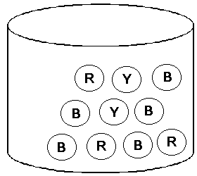  JAR WITH MARBLES  1. What is the probability of picking a yellow marble?  2. What is the probability of picking a red marble?  3. What is the probability of picking a blue marble?  4. What is the probability of picking a yellow and red marble?  5. What is the probability of picking a blue and red marble?  6. What is the probability of picking a yellow and blue marble? | Activity 2:  You select a marble without looking and then put it back. If you do this 9 times, what is the best prediction possible for the number of times you will pick a marble that is not brown?
- Developing mastery (Leads to Formative Assessment) | Pair Share:  Two dice marked 1-6 are rolled. Compute for the probability that the result will be a sum of 6. | Pair Share:  Toni makes a guess which day on September is Alex’s birthday. Toni knows that Alex’s birthday does not fall on an odd numbered day. What is the probability that Toni will guess the correct day on her first try? | Group Activity: Perform the activity and record the result.  The numbers 1,2,3,4,5 and 6 are shown as dots on the six faces of a die. If two dice are rolled, find the probabilities.  Example: What is the probability of getting the sum of 6?  Solution:  P(6)= (1,5),(5,1),(4,2),(2,4),(3,3) =5  1. P (sum of 4) ____  2. P (sum of 7) ____  3. P (sum of 2) ____  4. P (sum of 5) ____  5. P (sum of 9) ____  6. P (sum of 12) ___  7. P (sum of 13) ___  8. P (sum of 3) ____  9. P (sum of 10) ___  10. P (sum of 1) ___ | Group Activity: Perform the activity and record the result.  You want to find the probability of getting a “head”. You tossed a fair coin 20 times and record the result on the table.  Outcomes Tallies No. of Times Obtained  Head  Tail  a. What is the theoretical probability of getting a “head”?  b. What is the experimental probability of getting a “head”?
- Finding practical applications of concepts and skills in daily living | Out of 40 pupils of Section Jade of Narra Pilot School, 75% of the pupils are passing the exam. What is the probability of pupils failing the exam? How many are failing? | 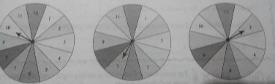  Use the information from the spinner to solve the problems. Use certain, likely, equally likely somewhat likely, or impossible for your answer.  1st 2nd 3rd  Spinner spinner spinner  1. What is the chance of landing on an odd number on 2nd spinner?  2.What is the probability of landing on an odd on the 3rd spinner?  3. Is it like, unlikely or equally likely to land on an even number on the first spin?  4. Lara added a 3 and 9 to the 3rd spinner. What is the probability now of landing on an odd number?  5. Luis removed 1,3 and 11 from the 1st spinner. What is the probability now of landing on an even number? | A basket contains 5 chicos, 3 atis, 4 mangoes and 6 avocados. If only one fruit, is drawn from the basket, find the probability of the following;  1. P (chicos) ___  2. P (atis) ____  3. P (not mangoes) ___  4. P (chicos or mangoes) __  5. P (mangoes) ____ | Refer to ,  APPENDIX -A  Investigating Experimental Probability  (separate sheet)  ACTIVITY 1: Odd or Even S
- Making generalizations and abstractions about the lesson | How do you quantify phrases “most likely to happen” and “unlikely to happen”? | Probability is a measure of the likelihood that a certain event will occur. It can be expressed as a number from 0 to 1. | How will you perform the experimental probability?  Do we need to record the outcomes? | How will you perform the experimental probability?  Do we need to record the outcomes?
- Evaluating learning | Solve:  In one bookstore, a saleslady sold 125 notebooks, 150 pencils, and 120 pad papers. Compute for the probability that she will sell a pencil, and the probability that the next item she will sell is not a pencil. ______,_______. | Solve:  A catalog store has 6% of its orders returned for a refund. The owner predicts that a new candle will have 812 returns out of the 16,824 sold. Do you agree with this prediction? Explain. | 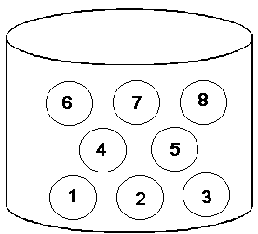  Directions: Study the illustration below then answer the following questions that follow.  THE CHIPS ARE PLACED IN A JAR AND MIXED  1. What is the probability of picking a chip with an even number?  2. What is the probability of picking a chip with an odd number?  3. What is the probability of picking a chip with the biggest number?  4. What is the probability of picking a chip with the smallest number?  5. What is the probability of picking a chip with a prime number? | 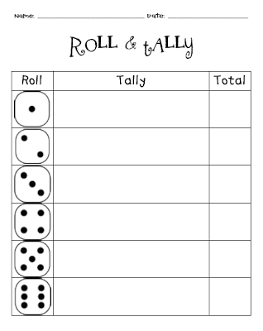  Roll a die 5 times then record the result on the sheet.
- Additional activities for application or remediation
IV. REMARKS
V. REFLECTION
- No. of learners who earned 80% on the formative assessment
- No. of learners who require additional activities for remediation
- Did the remedial lessons work? No. of learners who have caught up with the lesson
- No. of learners who continue to require remediation
- Which of my teaching strategies worked well? Why did these work?
- What difficulties did I encounter which my principal or supervisor can help me solve?
- What innovation or localized materials did I use/discover which I wish to share with other teachers?

